EMCH361 Mechanical Engineering Laboratory I, Fall 2022

Laboratory 4

DETERMINING Flow conditions of water with Variable pump Power

Vaught, Jacob
Section 006
Email: jvaught@sc.edu
Date: 11/6/2022
Department of Mechanical Engineering
University of South Carolina
Columbia, SC 29208

Abstract
This lab experiment was set up to determine the relationships between water and the flow properties with varied system conditions. It was determined that two of the three differential pressures had an inverse relationship with flow. The only differential pressure with a direct relationship was the Venturi differential pressure. It was determine that pump efficiency varied between 6% and 19%, while the error between the actual and measured flow was between 0.44% and -0.5%.

introduction

This lab explored the relationship of different water properties and sensor readings in different flow conditions. The setup can be seen in the Figure 1 below [1].
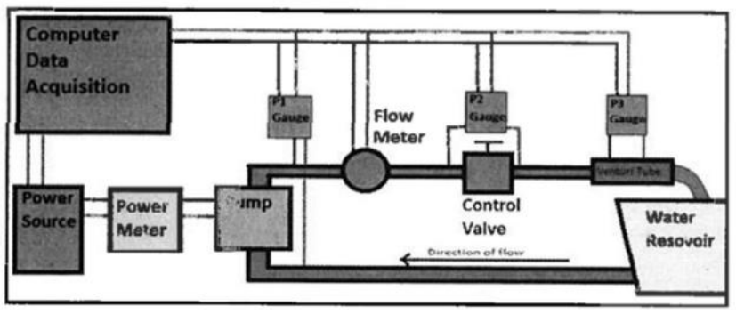
Figure 1. Fluid lab pump setup
The setup of this lab as seen in figure one contained a pump which had a power meter attached to it. The water from the pump then went through a flow meter, and through a valve which the students controlled. The valve was adjusted to let less fluid through it as the experiment went on to reduce the power usage of the pump. As the water exited the system, it went through a venturi flow meter. All the sensors were connected to LABVIEW. To calibrate all the sensors, the students put the system in a steady state, and measured the water flow rate in mL/s, which was converted into gpm to be used in the LABVIEW program. After this, measurements were taken on the computer. These steps then had to be repeated to calibrate the system for each trial.

$Water flow=\frac{collected water}{time of collection}$ (1)
$Percent error=\frac{\left|measured FR-Actual FR\right|}{Actual FR}*100\%$ (2)
$η=\frac{ΔP*Q}{W}*100\%$ (3)
$Q_{actual}=C*Q_{ideal}$ (4)
$Q_{ideal}=M*A_{2}*\sqrt{\frac{2*g_{c}}{ρ}\left(p_{1}-p_{2}\right)}$ (5)
The equation one is what students used to find the actual water flow of the system to calibrate it [3]. The percent error for the flow rate for each trial is found using equation 2 from reference [1]. The final equation used in this lab is the pump efficiency, 𝜂[1]. These equations are used in the excel spreadsheet we used.

Instruments

The main instrument used during this lab was the water flow apparatus which contained the paddle wheel flow meter, venturi flow meter, pump, reservoir, differential pressure gauge, and the control valve [1]. The power meter for the pump and the LABVIEW program on the laboratory laptop were the only 2 other external pieces of equipment. A National Instruments array was used to be able to connect the sensors to the laptop. A measuring cup and a timer were also used to measure actual flow rate.
The pump contained a data sheet about the flow rate and the sizes of all the different models [5]. This is the same for the pressure sensors which also had data specifications sheets for them [4]. The differential pressure sensors also contained a data sheet that students were able to reference for further understanding [6].

Lab Procedure
The water flow apparatus was already set up and filled with water by the teaching assistant by the time the students arrived to the lab. The students calibrated the system before each trial by measuring the flow rate of the water output and inputting that into the LABVIEW program which adjusted all the sensors to read correctly for that trial [1]. This had to be done for every trial. After calibrating, the data could be collected. The first trial is run with full power, while the second trial is run with 1 less watt than first trial, and finally the last trial is run with a half watt less from the second trial [2].

Results and Discussions
Table 1 shows all data collected and calculated.
Data: | Trial 1 | Trial 2 | Trial 3
Volume (mL) | 690 | 660 | 400
time(s) | 3.28 | 4.71 | 3.57
Actual Flow Rate (mL/s) | 210.3659 | 140.1274 | 112.0448
Actual Flowrate(Gpm) | 3.3659 | 2.2420 | 1.7927
Entered FR (gpm) | 3.36 | 2.24 | 1.8
Entered Flow Rate in M^3/s | 2.12E-04 | 1.41E-04 | 1.14E-04
Entered FR (M^3/s) | 2.12E-04 | 1.41E-04 | 1.14E-04
Paddle Wheel Flow Rate (gpm) | 3.38 | 2.27 | 1.78
Paddle Wheel Flow Rate (M^3/s) | 2.13E-04 | 1.43E-04 | 1.12E-04
Venturi Flow Rate (gpm) | 3.38 | 2.23 | 1.8
Venturi Flow Rate (M^3/s) | 2.13E-04 | 1.41E-04 | 1.14E-04
Venturi DP(inwc) | 7.53 | 4.68 | 2.51
Venturi Pressure(Pa) | 1875.639 | 1165.736 | 625.213
Pump Pressure Differential (psi) | 1.47 | 1.75 | 2.06
Pump Pressure Differential (Pa) | 10135.29 | 12065.83 | 14203.20
Valve Differential Pressure (psi) | 0.35 | 0.93 | 1.58
Valve Differential Pressure (Pa) | 2413.165 | 6412.124 | 10893.717
Power(W) | 22.6 | 21.9 | 21
Q(ideal)(M^3/s) | 4.01E-04 | 6.53E-04 | 8.52E-04
Q(ideal)(gpm) | 6.354 | 10.357 | 13.499
C | 5.29E-01 | 2.16E-01 | 1.33E-01
FR Error % | 0.4203% | -0.5369% | 0.4062%
n(efficiency) | 6.291% | 16.082% | 19.017%
Table one shows the data collected during the lab and all the required calculation data. All units were converted to SI. [3].

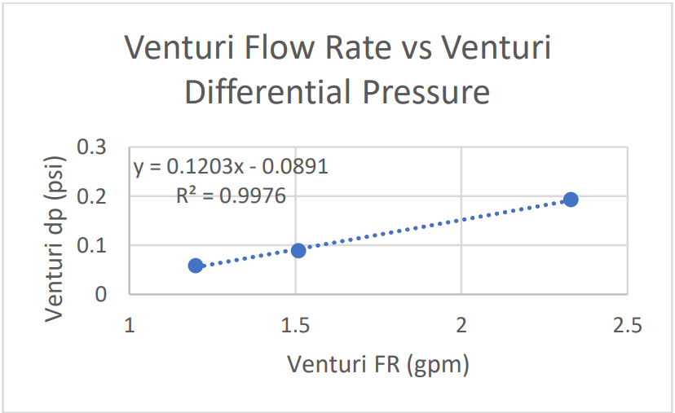
Figure 1: Shows Venturi FR vs Venturi dp
The graph one shows the relationship of the venturi sensor for differential pressure and flow rate through the experiments [3].

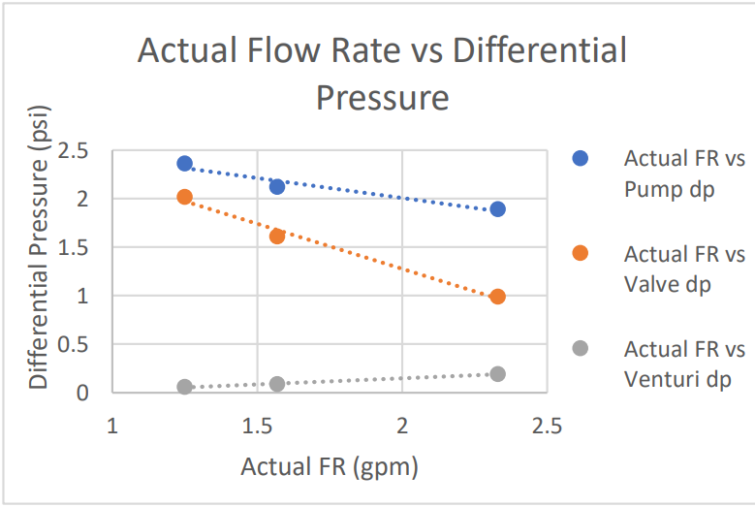
Figure 2 shows the relationship of actual flow rate and dP of different parts
The second graph shows the relationships of the differential pressures compared to the actual flow rate measured in the lab. meant the valve was being opened more so it allowed more free flowing. This meant less pressure lost occurred due to the valve restricting flow in the system.

CONCLUSIONS

In this lab the relationships of water properties in the system were determined. A direct relationship was noted for 1 of the data sets, while the other 2 had inverse relationships. The pump had an efficiency of around 16%, which is quite inefficient. The Flow Rate error between the Venturi and actual Flow Rate was approximately 0.5%.
The recommendations for this lab are to have the setup be more involved with the students.

ACKNOWLEDGMENTS
The author would like to thank Dr. Xingjian Xue and Lei Xu for their help in setting up and the aid provided during the experiment during the lab time. The half-witted lab was quite the experience for unintelligent students. The University of South Carolina must also be thanked for providing the funding to the engineering college to fund these extremely useful lab experiences, and one can only hope that they will improve in the future.

REFERENCES

[1] Xue, X., “Fluid Lab Introduction” Fluid Lab
[2] Xue, X., “In Person Lab Discussion” Fluid Lab.
[3] Vaught, Jacob, Lab Experiment Results.
[4] Honeywell, “Miniature Low-Pressure Sensors” Pressure Sensors
[5] Quiet One, “Quiet One 1200 Pump”
[6] Omega.com, “Low-Cost Wet/Wet Gage”

